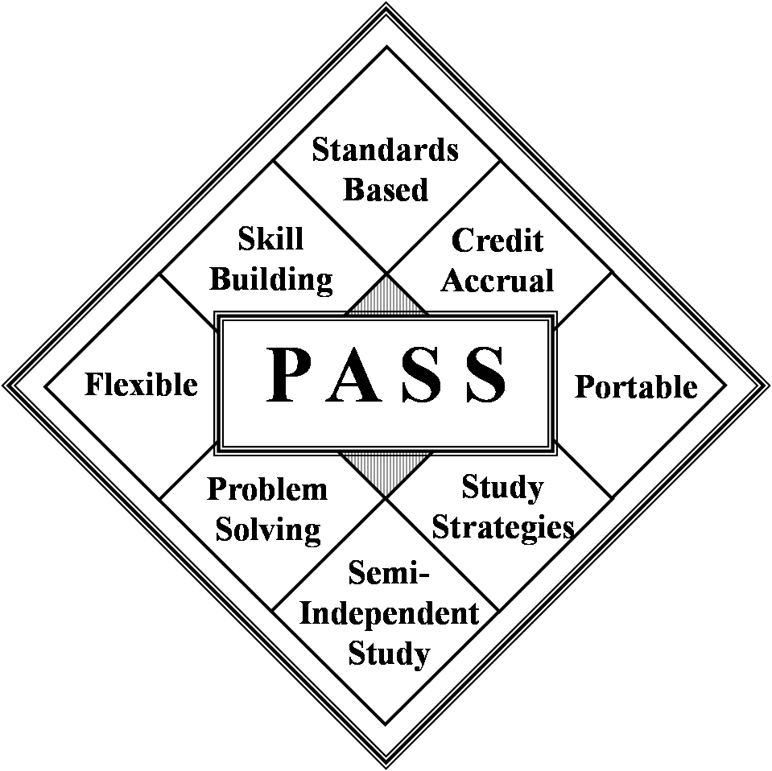 | IDEA - Midwest Region PASS Order Form  Fort Scott Community College  2108 South Horton Street, Fort Scott Kansas 66701  Office: (620) 223-2700 ext. 7720 Fax: (620) 223-4927  Email: pamh@fortscott.edu | 

School/Entity Name: __________________________________________________________Date: ______________

Shipping Address: _____________________________________

________________________________________________________________________________________

Billing Address (if different than above): _____________________________________________________________
Contact Name: ___________Phone: _______________________________________
- Course cost: $80/course + shipping will be added to your invoice after shipment. Mentor Manual cost: $20 each
- Cost is non-refundable.
- Parent Permission is required for the Health Course.
- *Course also available in Spanish. Please note if you would like the course in Spanish.
- #Course created for Migrant Students only
- FSCC provides instructional materials only and does not provide auxiliary services such as grading or issuing transcripts.
- By ordering these courses, the entity agrees, understands, and will honor all copyrighted materials.
Courses | Qty | Mentor | Courses | Qty | Mentor
Language Arts |  |  | Social Studies
Creative Writing |  |  | Global History and Geography A
English 1A |  |  | U.S. Government*
English 1B |  |  | U.S. History A*
English 2A |  |  | U.S. History B*
English 2B |  |  | World History A
English 3A |  |  | World History B
English 3B |  |  | World Geography
English 4A |  |  | World Geography A
English 4B |  |  | World Geography B
Learning English through Literature |  |  | Economics with Financial Literacy*
 |  |  | Contemporary World Problems
Mathematics |  |  | Science
Algebra 1A* |  |  | Biology A (includes Bilingual Biology Glossary)*
Algebra 1B* |  |  | Biology B (includes Bilingual Biology Glossary)*
Algebra 2A |  |  | Environmental Science A
Algebra 2B |  |  | Environmental Science B
Integrated Math Concepts* |  |  | General Science A
Geometry A |  |  | General Science B
Geometry B
Personal Finance* |  |  | Additional Instructional Resources
General Math A
General Math B
Electives |  |  | Generic Novel – Cost $30
Your Health* |  |  | Reading on the Move# - Cost $30 |  | NA
Study Skills |  |  | Math on the Move*# - Cost $80 |  | NA
Career Connections* |  |  | Math for Living*# - Cost $30 |  | NA
Color & Design
Consumer Education
Learning Skills
INVOICE INFORMATION: Course Total_____ x $80 = $_______Mentor Manual Total_____ x $20 = $_______;
Additional Resources_______ x $30 = $_______. GRAND TOTAL = $________________

