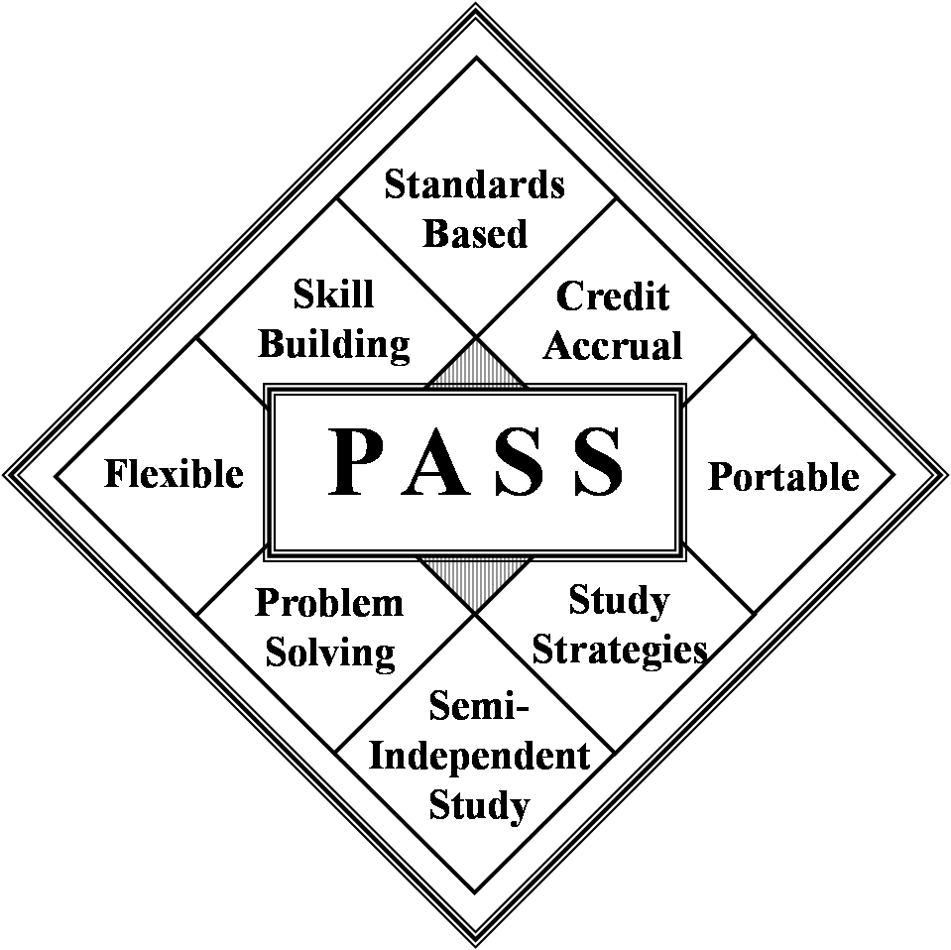 | IDEA- Midwest Region PASS Center  Middle School PASS Order Form  Fort Scott Community College  2108 South Horton Street, Fort Scott Kansas 66701  Office: 620-223-2700 ext. 7720  Fax: 620-223-4927 | 
School _________________________Date ____

Shipping Address __________________

___________________________________________________________________________

Contact Person ________ _____________Phone________ ____________

Email_______________________________________________________________________

- Course Cost: $80 each; Mentor Manual Cost: $20 each. Shipping will be added to the invoice after shipment. Cost is non-refundable.
- FSCC provides instructional materials only and does not provide auxiliary services such as grading, or issuing credits or transcripts.
- By ordering these courses, the entity agrees, understands, and will honor all copyrighted materials.
- Please email order to: pamh@fortscott.edu@fortscott.edu

COURSE TITLE | QUANTITY | MENTOR MANUAL
Reading
Reading 6A*
Reading 6B*
Reading 7A*
Reading 7B*
Reading 8A*
Reading 8B*
Language Arts
Language Arts 6A
Language Arts 7/8A
Language Arts 7/8B
Social Studies
History of the United States A
History of the United States B
Mathematics
Math 6A
Math 6B
Math 7A
Math 7B
Math 8A
Math 8B
Science
Life Science 7A
Life Science 7B
Earth Science 8A
Earth Science 8B

*All Reading Courses have not been updated since 1999.

INVOICE INFORMATION: Course Total_____ x $80 = $_______Mentor Manual Total_____ x $20 = $_______;
Additional Resources_______ x $30 = $_______. GRAND TOTAL = $________________

